**LOGIN PAGE:**

Program:

<!DOCTYPE>

<html>

<head>

<META http-equiv="Content-Type" content="text/html; charset=utf-8">

</head>

<body>

<div>

<p><p>

<form target="_blank" onsubmit="try {return window.confirm(&quot;You are submitting information to an external page.\nAre you sure?&quot;);} catch (e) {return false;}">

<label><b>Username:</b></label>

<input type="text" name="uname"><br><br>

<label><b>Password:</b></label>

<input type="password" name="psw"><br><br>

<a href=" file:///C:/Users/srinidhi/Desktop/ni.html ">Next</a><br>

</a>

</form>

</p></p></div>

</body>

</html>

**QUIZ PAGE**

Program:

<html>

<head>

<h1>State True or false</h1>

</head>

<body>

<p id="demo"><p>

<form>

<p>1.HTML is used for designing web pages</p>

<input id="q1" type="radio" name="Gender" >True

<input id="q12" type="radio" name="Gender" >False

<p>2.HTML stands for hyper text markup level</p>

<input id="q2" type="radio" name="Gender1" >True

<input id="q22" type="radio" name="Gender1" >False

<p>3.CSS stands for cascading style sheets</p>

<input id="q3" type="radio" name="Gender2" >True

<input id="q32" type="radio" name="Gender2" >False

<p>4.html tag doesnt require close tag</p>

<input id="q4" type="radio" name="Gender3" >True

<input id="q42" type="radio" name="Gender3" >False

<p>5.h1 is bigger than h2</p>

<input id="q5" type="radio" name="Gender4" >True

<input id="q52" type="radio" name="Gender4" >False

</form>

<button type="submit" onclick="pass2()">submit</button><br>

<script>

function pass2(){

var count=0;

if(q1.checked){count=count+1;}

if(q22.checked){count=count+1;}

if(q32.checked){count=count+1;}

if(q42.checked){count=count+1;}

if(q52.checked){count=count+1;}

document.write("Result:"+"Total marks scored="+count);

}

</script>

</body>

</html>

OUTPUT:

THIS IS THE PAGE TO ENTER THE USER NAME AND PASSWORD

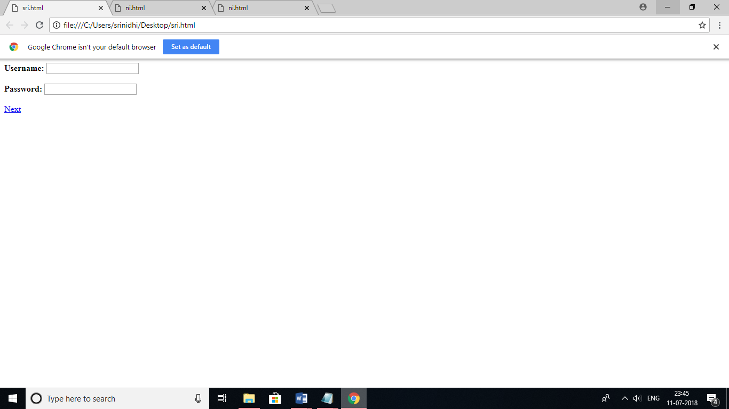

IN THIS PAGE WE CAN OBSERVE THE ENTERED USERNAME AND PASSWORD AND THERBY CLICKING THE NEXT IT WILL DIRECT TO NEXT PAGE

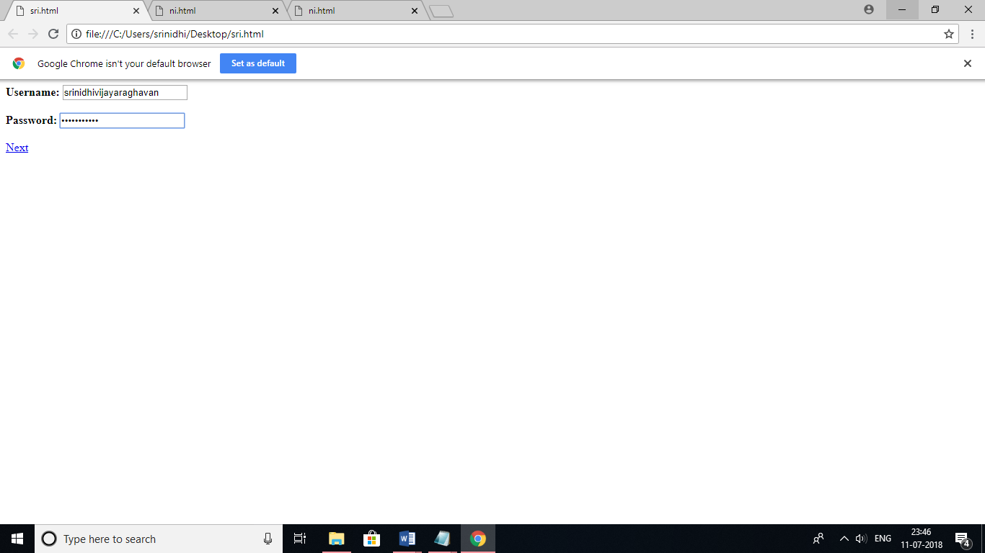

THIS IS THE NEXT PAGE WITH SET OF QUESTION TO BE ANSWERED

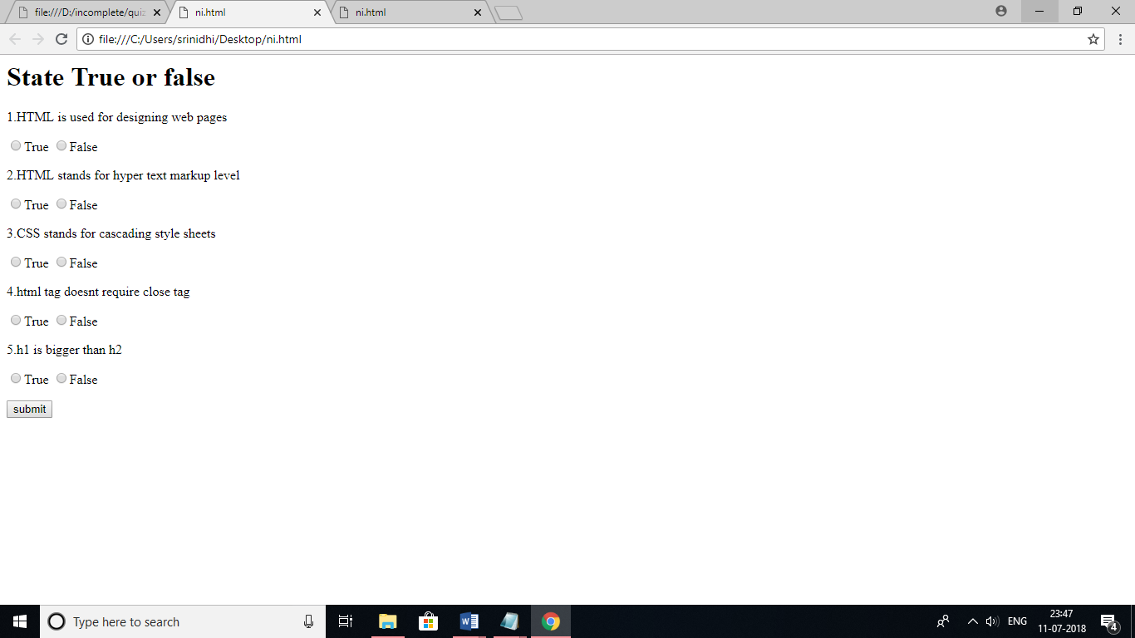

THUS DISPLAYED HERE IS THE ANSWERED SHEET AND THERBY CLICKING THE SUBMIT BUTTON ITS DIRECTS TO THE NEXT PAGE WITH IS THE RESULT PAGE

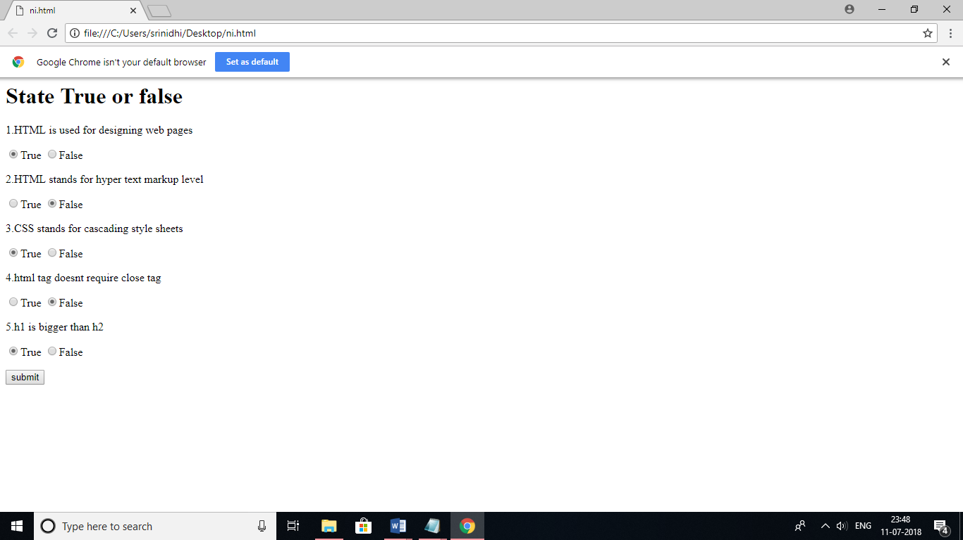

THIS PAGE IS THE RESULT PAGE FOR THE ABOVE PAGE ANSWERED USER IN THIS U CAN SEE THE SCORE

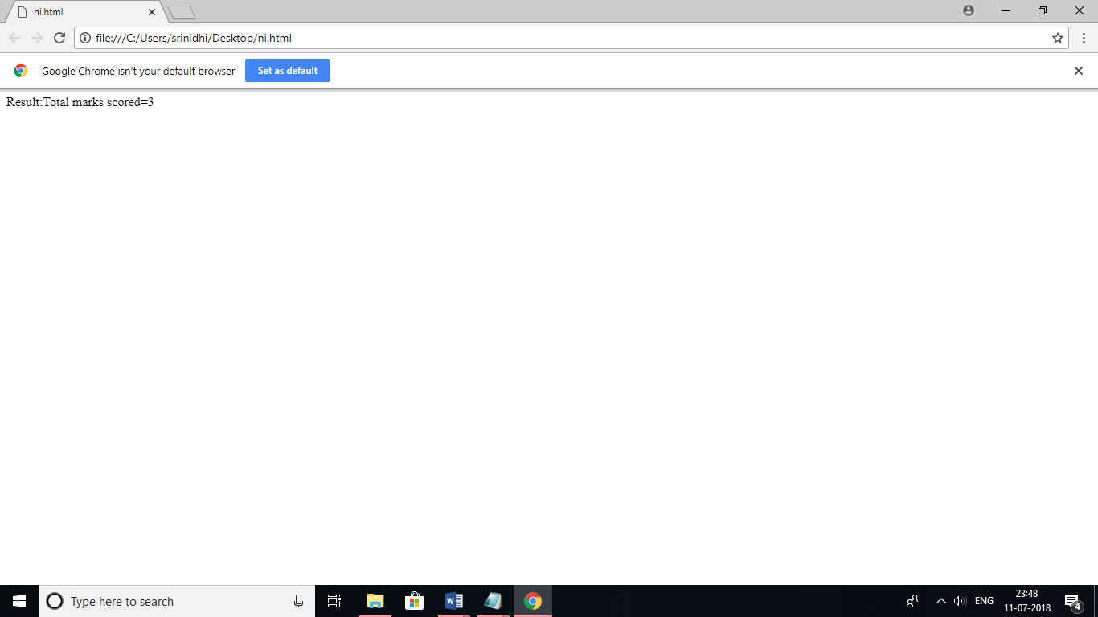

RESULT: